**Installing JDK 1.8 on Linux box using Ansible playbook**

Installing Ansible on CentOS 7

Adding repository:

[root@localhost admin]# yum install -y epel-release

[root@localhost admin]# yum install -y epel-release

]]]

Update:

[root@localhost admin]# yum update -y

[root@localhost admin]# yum install -y epel-release

Installing Ansible:

[root@localhost admin]# yum install -y git python python-devel python-p:p openssl ansible

[root@localhost admin]# yum install -y epel-release

Edit your ansible configuration:

[root@localhost admin]# vim /etc/ansible/ansible.cfg

[root@localhost admin]# yum install -y epel-release

Uncomment inventory and sudo_user as shown below.

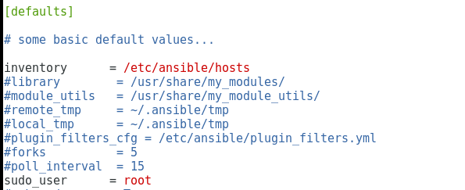

Let’s add a CentOS node, to do that; type **vi /etc/ansible/host**.

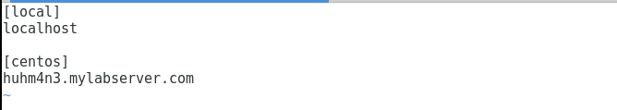

Now let’s configure our localhost as well as nodes by typing **visudo**.

ansible ALL=(ALL) NOPASSWD:ALL

%sudo ALL=(ALL:ALL) NOPASSWD: ALL

We have to add these two lines underneath of root as shown in the picture. This will help to run not only sudo command but not to require password when we are running ansible playbooks. Ansible playbook will fail, if it has to pause and ask for a password.

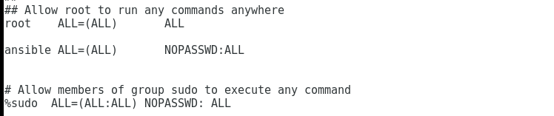

That’s how your ansible playbook should look:

(you can copy the code from jdk.yaml)

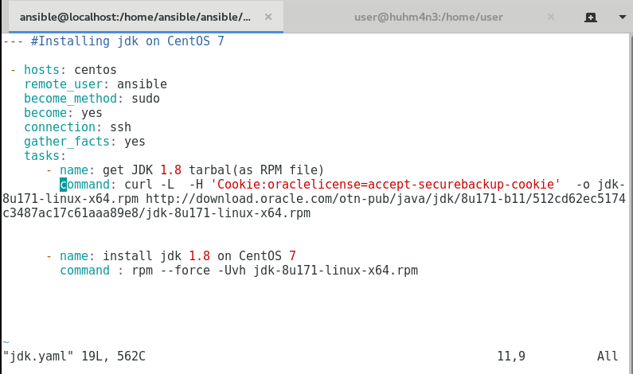

To run ansible playbook, type **ansible-playbook your_filename.yaml**.

(For e.g. **ansible-playbook jdk.yaml**)

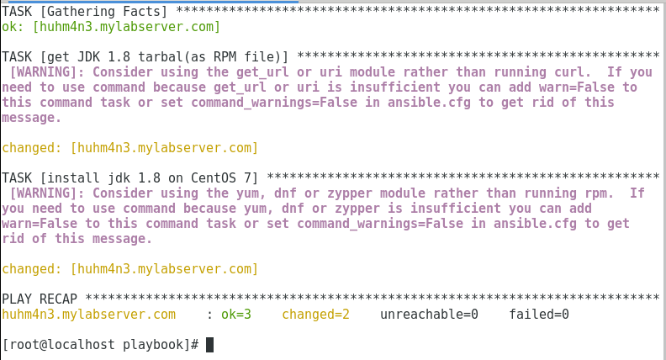

To check whether java is installed or not on the CentOS node, type **java -version**.

